Distributed Systems and Co-Operative Computing

**RMI Assignment**

# Luke Slemon – 16421694

**Sam Duignan -**

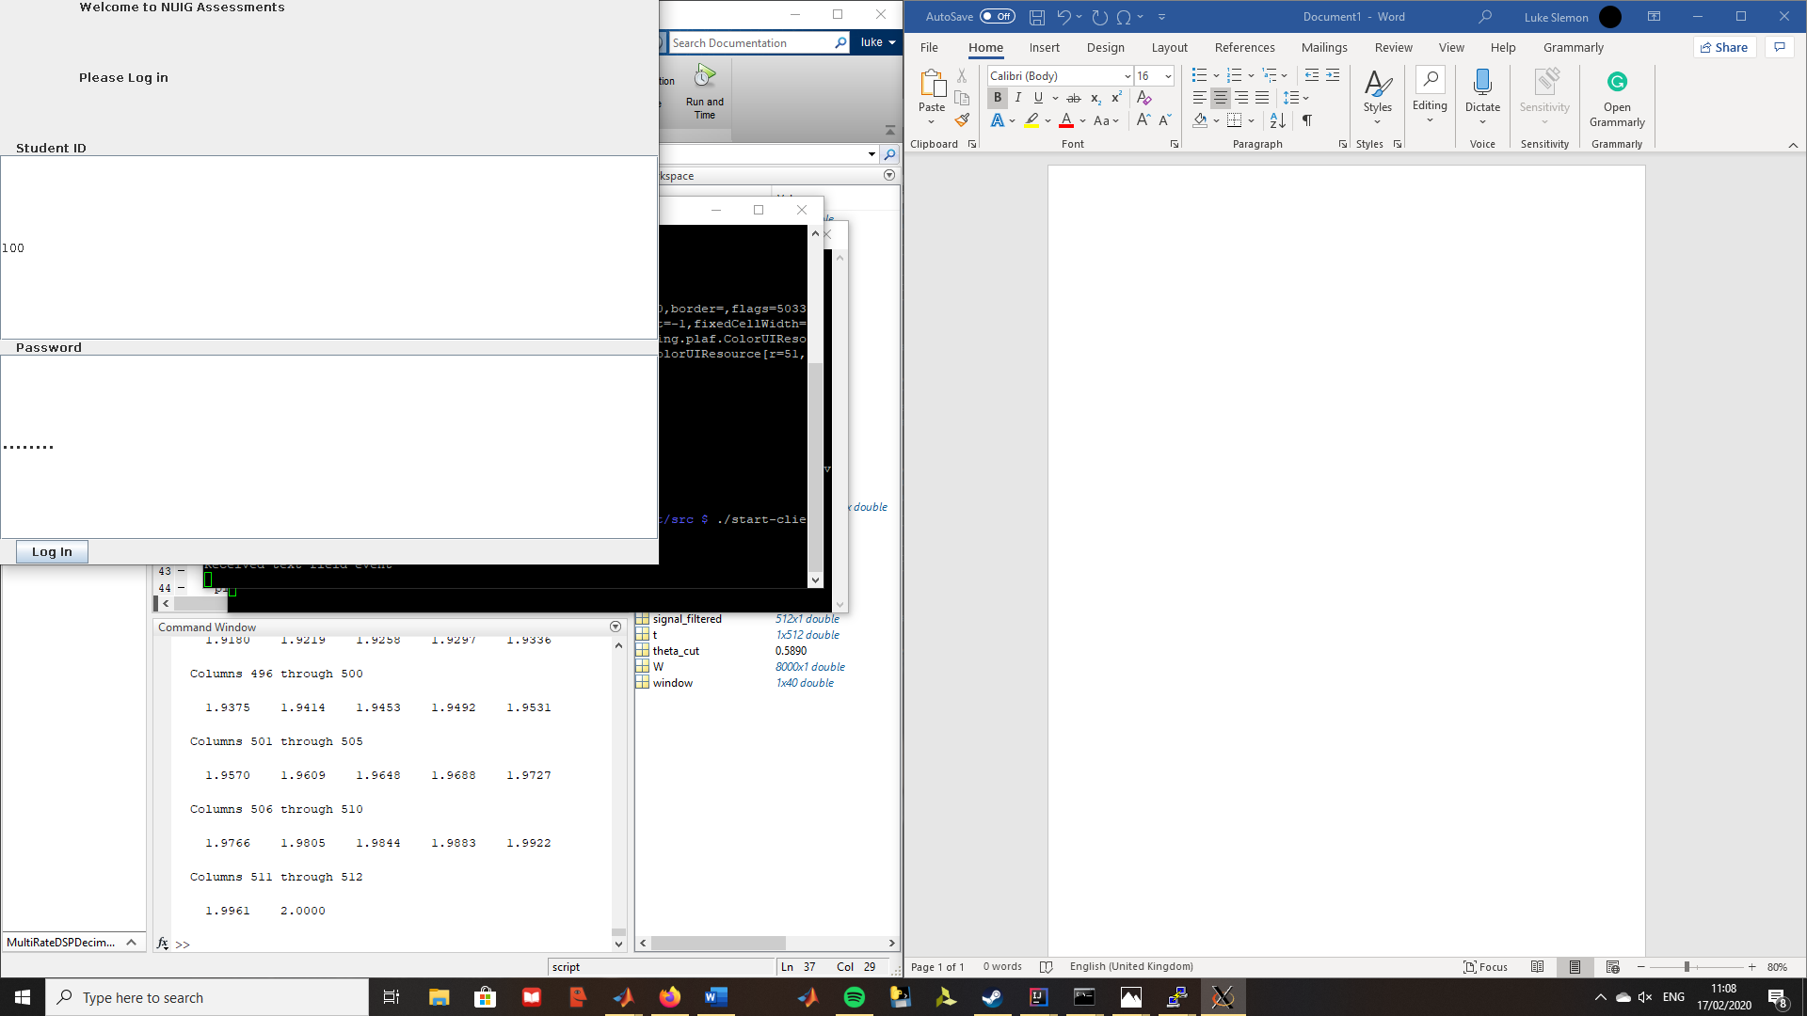

## Figure 1. Log in screen

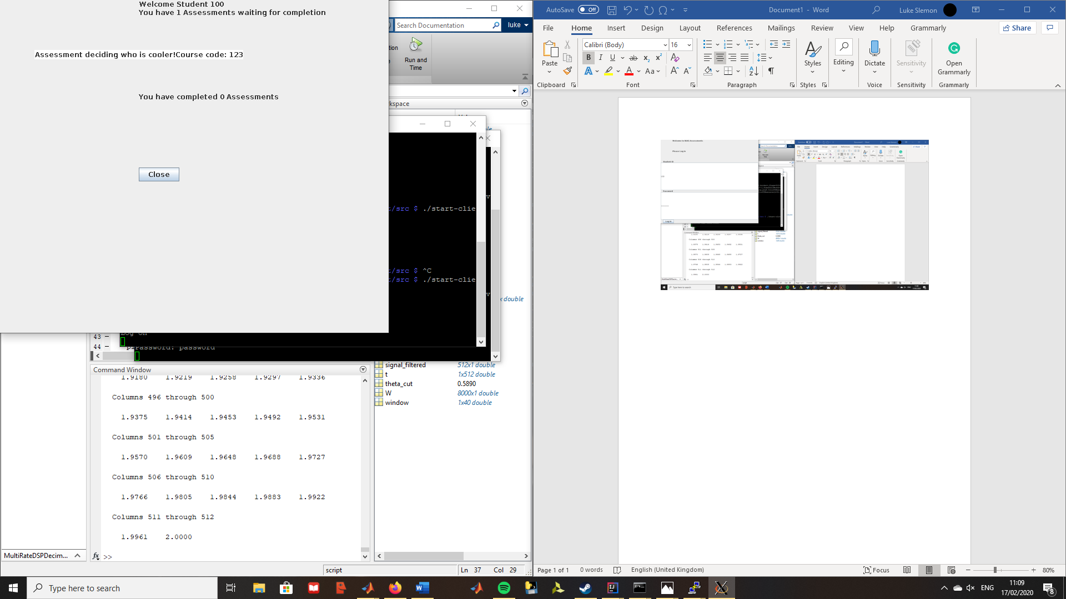

## Figure2. Assessment Summary Screen

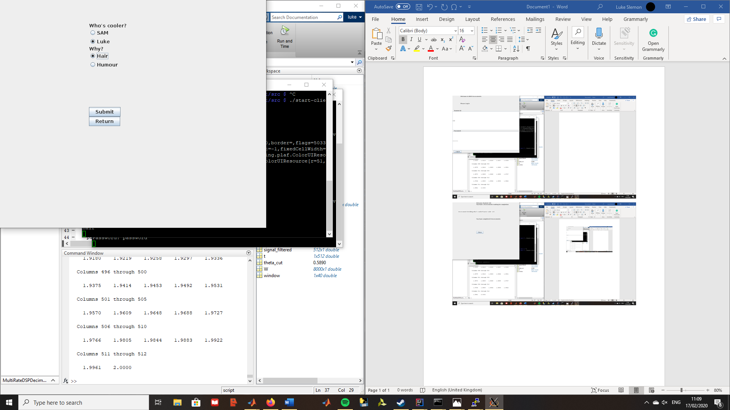

## Figure3. Assessment Questions Screen

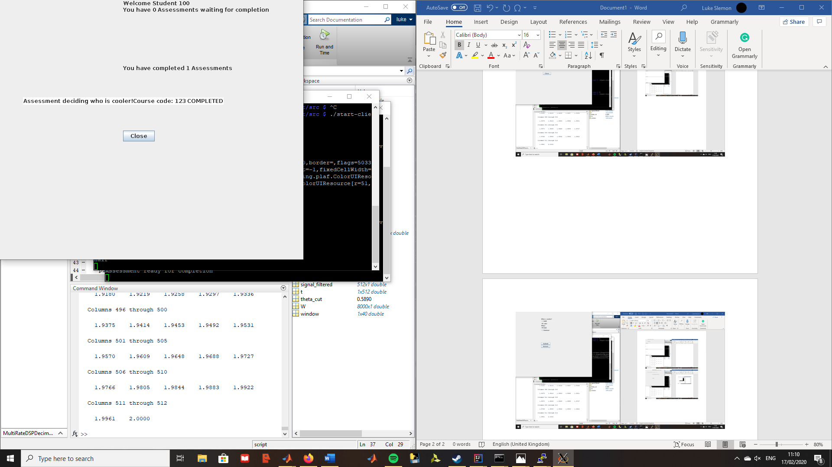

## Figure4. Assessment Summary screen after submitting assessment